**Y10 Test 2 Revision Worksheet**

1. In Foxes, the gene for red coat colour **(R**) is dominant to the gene for silver-black colour (**r**). Determine the genotype and phenotype percentages/ratios expected for the following crosses:

* 1. silver-black coat male with a heterozygous red female

2. In human beings, the gene for brown coloured eyes is dominant to the gene for blue coloured eyes. A blue–eyed man marries a brown-eyed female and they have three children. Two of the children have brown eyes and one has blue eyes.



* 1. What are the genotypes of the mother and the father?
  2. What is the chance that their next child will have blue eyes?

3. A boy wanted to work out what his blood type would be. He knew his father had blood type **AB** and his mother had **O**. What blood types could he possibly be? Explain your answer.

4. Colour blindness in humans is a sex-linked characteristic. A dad who was colour-blind and a mum who was a carrier for colour-blindness had 2 children, one boy and one girl.

(a) What is the chance the boy will be colour-blind?

(b) What is the chance the girl will be colour-blind?

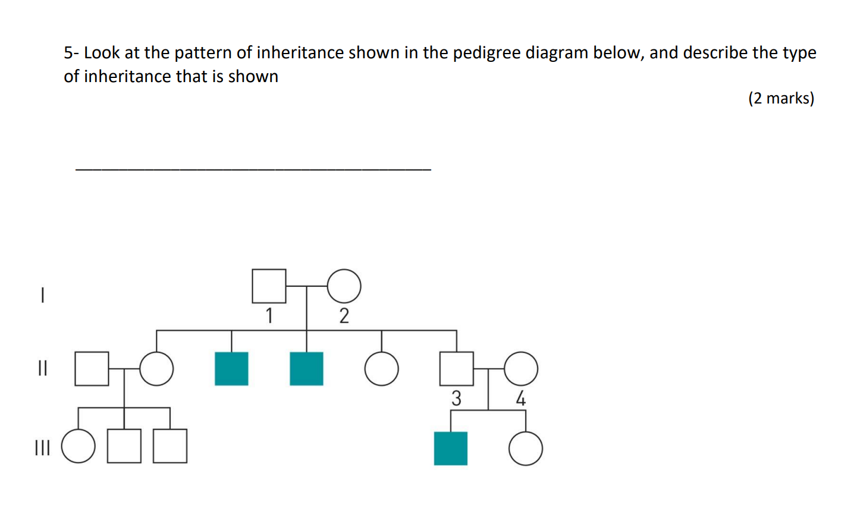

6. Alkaptonuria or Maple Syrup disease is a rare genetically inherited disease found in humans. In this disease the urine contains a substance which gives it a dark brown colour which turns black on exposure to air. The family tree below shows a family containing some individuals who have Alkaptonuria (shaded).

j0292244

1

2

4

3

6

5

7

8

9

10

11

13

12

1. Is alkaptonuria dominant or recessive? Explain your reasoning.
2. Determine the genotype of individuals 1, 4, 10, and 11. Explain your reasoning for each answer.

7. Suppose a white, straight haired guinea pig mates with a brown, curly haired animal. All five babies in their first litter have brown fur, but three are curly and two have straight hair. The second litter consists of six more offspring, all with brown fur – but two are curly and four are straight haired.

Assuming curly is dominant to straight, what are the genotypes of the parents and the offspring?

8. What is the definition of a species?

9. Explain what is meant by speciation?

10. List the three main steps in the process of speciation.

11. Explain how fossils support the theory of evolution.

12. Explain why a barrier is necessary before speciation can occur.

13. Use the model of speciation to explain why isolated islands have a high proportion of species not found elsewhere even on nearby mainland.

14. Distnguish between

a) evolution and natural selection.

b) speciation and natural selection.

c) evolution and speciation.

15. List 5 evidences to support the theory of evolution.

16. What is the difference between divergent and convergent evolution?

17. Colour blindness is inherited as a sex-linked recessive. Write, as far as possible, the genotypes of each person in the following pedigree. Black circles indicate colour blind persons.

18. In mice there is a coat colour gene called Tabby (T) located on the X chromosome. What genotypes would be expected among the offspring of a Tabby XO female mated with a normal grey coloured (t) male? (At least one X chromosome is needed for the embryo to survive)

19.Consider the pedigree for the inheritance of “faulty tooth enamel”

1. State how many generations are shown in the pedigree
2. Identify the phenotype of individual II2, II4 and II8
3. Identify the relationship between individual II5 and III7
4. Write down the genotypes for all even numbered individuals.
5. Identify if this a dominant or a recessive disorder, and explain how you know this.
6. Does individual I1 have a heterozygous or a homozygous genotype? Justify your answer.

20. Down below Tasmania, there is an island called Bleak Island, home to a unique species of penguins called snow penguins. Most snow penguins are white although a small percentage are grey. Scientists believe this is because the penguin hatch (from eggs) when there is snow cover on the ground. The white hatchlings are better camouflaged than the grey hatchlings, and are therefore better protected from birds of prey. Most of the white hatchlings survive, but most of the grey hatchlings are preyed upon and do not survive.

However, the climate on Bleak Island is changing, and in the last few years, the penguins have been hatching when there is no snow cover. Use your knowledge of Darwin’s theory of evolution by Natural Selection to describe how you would expect the penguin population to change.